Style Guide and Playtesting

Style Guide:

So for the general look and feel for the movie and the game, we are thinking of Okami kind of style, or legend of Korra episode with Wan. Rounded edges with an Inked feeling to it.

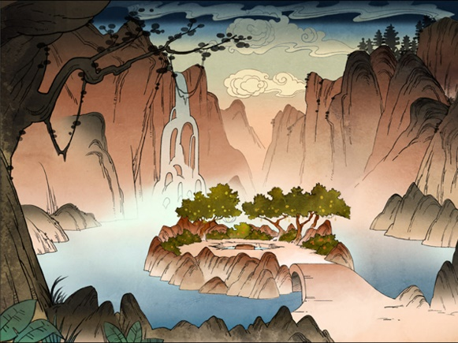 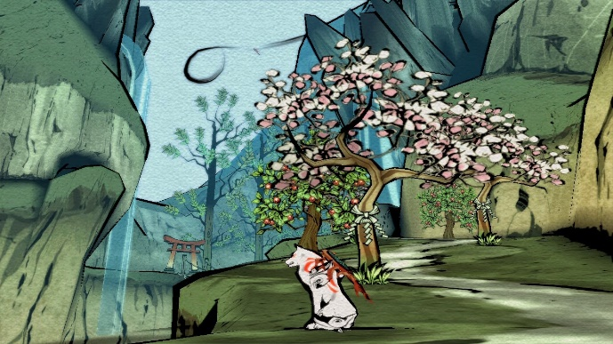

Color Palette-

Gradients, but maybe softer colors then what I’ve got here.



With the forest, the colors will be warmer and rich. Forest Greens and Chocolate Browns.

With the Swamp, I’m thinking of softer cooler colors. Light Greens and Blues and Grays.

With the Temple, the colors will be vibrant on objects and lights among the stone gray walls.

I’m thinking of having the background be mostly 2D, whereas the midground and foreground will be a mixture of 2D and 3D, but mostly 3D.

Lighting-

I have a darker lighting in the forest, with fireflies providing a warm glow.

In the swamp, it’s brighter like day time, but with effects to make it spookier or more mysterious.

In the temple it’s dark, but has different lighting in each room to provide a different feel and effect for each room.

VFX-

For visual effects, I might put fire into the temple as torches, I have fog in my swamp area, and fireflies in my forest. At the end I might try to figure out how to add fireworks for completing the game.

Audio-

I will probably use the music from the animation as background music for my game. And then go in and put in footfalls, insect noises, enemy sounds, grunts, etc, as needed.

Playtesting:

Things I need to end up fixing are

-tutorial at beginning

-fixing some triggers

-add something to the forest area

-make the jump boost more obvious

-Make a few other things more obvious

-Maybe a take away the backtracking

Here are a couple of the surveys I got back from a couple playtests.

Game Prototype Survey

Was the forest area long enough?

Compared to the other objects you need to grab, yes. Perhaps an extra small puzzle might be nice.

Did you know where to go and what to do?

For the most part, yes. It was pretty easy to tell when I couldn't enter an area, so I would go the other way.

Was it too hard or too easy?

Right in between. The temple was obviously the harder part of the game, but it wasn't tough necessarily, just mildly frustrating. ;)

Should there be more/less enemies?

I think the amount you had was great. Maybe if you added some enemies in forest area, it would make it longer.

Should there be more health options or power ups?

That part was great. :) Maybe a spped up power because there are areas that are longer (alligator are), but otherwise it was good.

Did you have fun?

Yerp!

Any comments, questions, suggestions, or rude remarks?

Only thing I can think of is the water/swamp areas becuase it was harder to jump in.

Thanks so much for playing and giving feedback!!!

Game Prototype Survey

Spencer B.

Was the forest area long enough?

Was the forest the part at the beginning that goes to the left? I think it was, I might add something super uber simple at the beginning just to teach the principle of picking up and dropping the things

Did you know where to go and what to do?

It was a little bit confusing, and took me a while to figure out that it was those wafer steps that were allowing me to jump high..

Was it too hard or too easy?

It wasn't too hard or too easy, but I did get stuck several times, haha

Should there be more/less enemies?

I think the enemy amount was good. The enemy by the red/green puzzle killed me really fast.. I think this would be really hard if we had limited lives

Should there be more health options or power ups?

Were there any? I didn't notice those..

Did you have fun?

Yes, I did.

Any comments, questions, suggestions, or rude remarks?

I just think it could use a little more player training at the beginning.. before you get to anything dangerous. For example, make it so the player cannot even start the journey until they demonstrate that they know certain mechanics..

with the wafer jumping, you could do something super obvious with it at first, like give them something to jump onto that is too high.. when they try that a couple times, have a wafer appear that lets them jump up there.. you know?

..The camera seems really far away from the player.

Thanks so much for playing and giving feedback!!!